34.67: a) 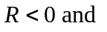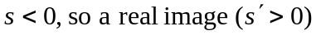 is produced for virtual object positions between the focal point and vertex of the mirror. So for a 24.0 cm radius mirror, the virtual object positions must be between the vertex and 12.0 cm to the right of the mirror. b) The image orientation is erect, since 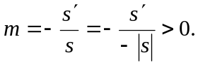
c)

